**Customer Acquisition Cost (CAC) Analysis Report**

Customer Acquisition Cost (CAC) is a crucial metric in evaluating the effectiveness and efficiency of a company's marketing strategies. It denotes the average expense incurred by the company to acquire a single customer. Analyzing CAC aids in optimizing marketing approaches, resource allocation, and enhancing Return on Investment (ROI).

**Dataset Overview:** The provided dataset encompasses the following columns:

* Customer_ID: Unique identifiers for customers.
* Marketing_Channel: Indicates the specific marketing channel through which customers were acquired (e.g., Email Marketing, Online Ads, Social Media).
* Marketing_Spend: The expenditure on marketing for each channel.
* New_Customers: The count of new customers acquired through each marketing channel.

**Analysis Process**

1. **Customer Acquisition Cost Calculation:**
   * I Computed the CAC by dividing 'Marketing_Spend' by 'New_Customers'.
   * I calculated and added a CAC value to the dataset, helping the company understand how efficiently it is acquiring customers through its marketing efforts and which marketing channels are more cost-effective for customer acquisition.
2. **Visualization of CAC by Marketing Channel:**
   * I Presented CAC variations across different marketing channels using a bar plot. So, looking at the customer acquisition cost of Email marketing is the highest and social media is the lowest.

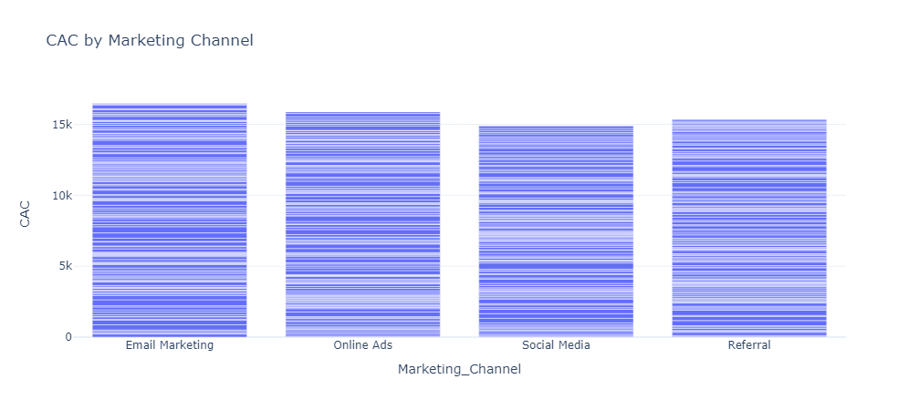

1. **Relationship between New Customers and CAC:**
   * I Explored the correlation between 'New_Customers' and 'CAC' to analyze the impact of acquisition volume on cost.

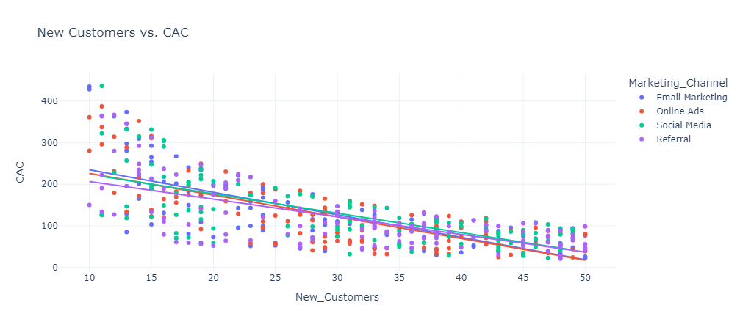

This negative slope indicates that channels with a higher number of new customers tend to have a lower CAC. In essence, as marketing efforts become more effective in acquiring customers, the cost per customer tends to decrease.

**Summary Statistics for CAC by Channel:**

* + Calculated descriptive statistics for CAC across various marketing channels.
  + By understanding the above summary statistics, we can:
  1. Use the mean CAC values to compare the average cost of customer acquisition across different Marketing Channels. For example, if minimizing CAC is a priority, you may want to focus on channels with lower average CAC values.
  2. Use the standard deviation to assess the consistency of CAC within each channel. Higher standard deviations suggest greater variability, which may require further investigation to understand the reasons behind the fluctuation in costs.
  3. Use quartiles to understand a sense of the distribution of CAC values. For example, if you want to target cost-effective customer acquisition, you might focus on channels where the first quartile (25%) has relatively low CAC values.
  4. Similarly, the minimum and maximum CAC values provide an understanding of the range of costs associated with each channel, enabling a grasp of potential cost extremes

1. **Conversion Rates by Marketing Channel:**
   * Derived insights on conversion rates across different marketing channels using a bar plot.

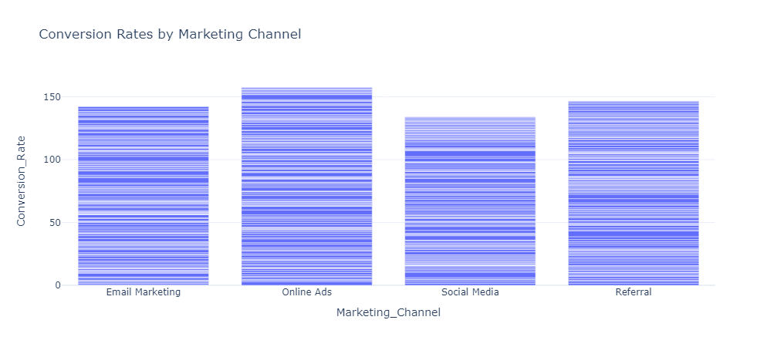

Based on the above analysis, online ads demonstrate better conversion rates than other channels**.**

1. **Break-Even Customers Calculation:**
   * Determined the number of break-even customers for each marketing channel.
   * Break-even customers refer to the number of new customers that a company needs to acquire through a specific marketing channel to cover the costs associated with that marketing channel. When the actual number of new customers acquired through the channel exceeds the break-even number, it indicates that the marketing efforts are generating more revenue than the costs, resulting in a profit.

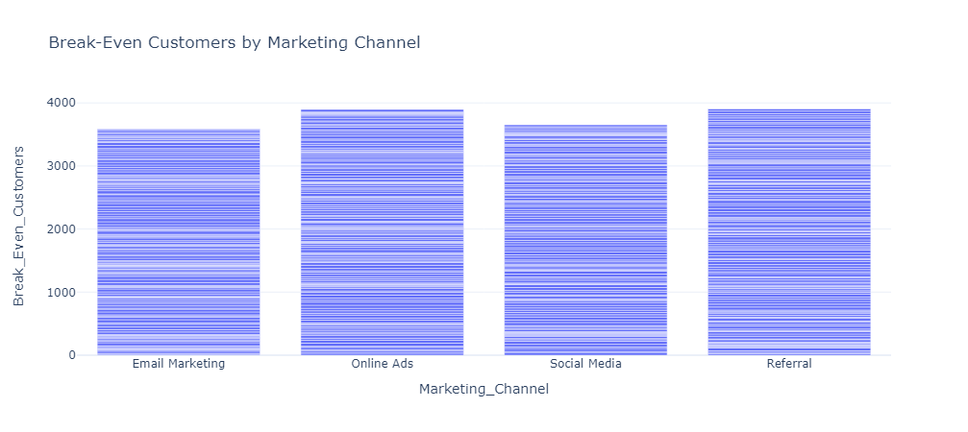

1. **Comparison of Actual vs. Break-Even Customers:**

* Visualized the comparison between actual and break-even customers across channels.

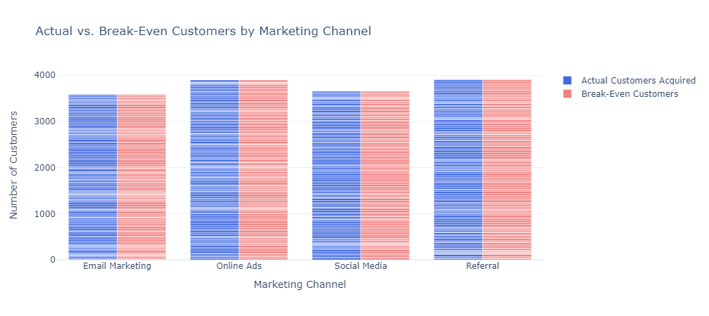

So, this shows a positive result of the marketing campaign as the actual customers acquired from all marketing channels exactly match the break-even customers. If the actual customers acquired were short of the break-even point, it would have indicated a need to reassess marketing strategies or allocate additional resources to those channels.

**Insights and Recommendations:**

* **CAC Comparison:** Identified Email Marketing with the highest and Social Media with the lowest CAC.
* **Correlation Analysis:** Discovered a negative correlation between CAC and New Customers, suggesting that more effective marketing tends to lower the cost per customer.
* **Summary Stats Interpretation:** Utilized mean, standard deviation, quartiles, min, and max values to assess CAC distribution within channels.
* **Conversion Rates:** Analyzed Conversion Rates, with Online Ads showing higher rates compared to other channels.
* **Break-Even Analysis:** Evaluated Break-Even Customers, indicating profitability when actual acquisitions meet or exceed this threshold.

**Conclusion:** Customer Acquisition Cost (CAC) analysis provides essential insights into the cost-effectiveness of marketing efforts. Optimizing marketing strategies based on channel-specific CAC values is vital for improving ROI and overall business growth..

By continuously monitoring CAC metrics, focusing on channels with lower CAC, and refining strategies to enhance conversion rates, businesses can optimize their marketing endeavors effectively.

This report underscores the significance of CAC analysis and the actionable insights it offers for refining marketing strategies, ultimately contributing to sustained business growth and profitability.